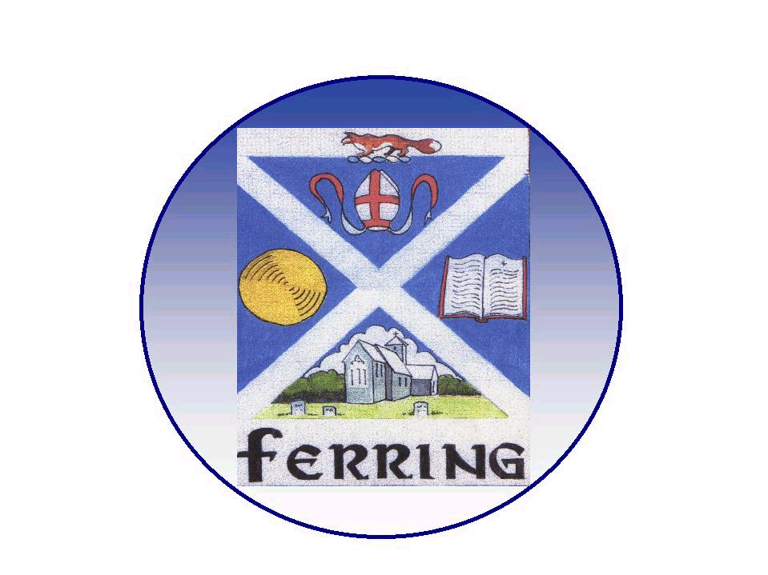
FERRING PARISH COUNCIL

1 Elm Park, Ferring, Worthing, West Sussex. BN12 5RN
telephone 01903 249 449 e-mail parishoffice@ferringparishcouncil.org.uk

Ferring Parish Council

General Parish Issues Committee (GPI)
(Advisory Powers)

To: Councillors Ruth Arnold, John Tero, Clare Royal & Paul Moss

Outside Representatives
FRSA Gardens
FRSA Roads: (Graham Groom)
Conservation Group: (David Bettiss)
Tree Warden: (Philip Ellis)
Glebelands/Football Club: (Andy Wincell)
Tennis Club: (Les Goodwin) – Finances to review

Your attendance is requested at a meeting of the General Parish Issues Committee to be held on Monday 27th June 2022 at 7.00pm at the Village Hall in the Club Room.

Members of the Public are welcome to attend the meeting and will be given an opportunity to make representation to Council under agenda item 5 on matters on this agenda only.

AGENDA

- Elect a Chairman

- Elect a Vice Chairman

- Apologies for Absence

- Declarations of Interest - members are reminded to make any declarations of personal and/or prejudicial interest that they may have in relation to items on this agenda.

- Public Question Time - 15 minutes has been reserved for members of the public
to address the Council on any subject related to items on the agenda only. (Standing Order 1e)

Each member of the public is entitled to speak once and shall not speak for more than three minutes. (Standing Order 1g)

- To agree Terms of Reference – to consider Terms of Reference (circulated to Committee Members)

- For information
- Silver Jubilee Plaque
- Boat Planter update
- Pantiles ditch clearance

- Issues to be raised

Highways
- Two mobile homes long term parking in Greystoke Road
- Proposal for TRO - at mid village shops
- TRO Greystoke Road adjacement to Church

Community
- Future of planter by Community Noticeboard
- Noticeboard – future of the surplus notice board
- Bus Shelter proposal – Langbury Lane
- War Memorial Flag pole Inspection

Environment & Amenities
- Ferring Nurseries Contract – Cllr John Tero
- Pantiles Tree – annual inspection
- Green Canopy – Plant a tree
- Warren pond Project & reptile
- Allotment Inspection / representative

- South Downs National Park Authority. National Park Authority are keen to help as
many communities as possible address climate change challenges. They have asked that parishes return the completed survey by 10th July 2022.

- Action in Rural Sussex Survey – Rethinking our Local Places and Communities. Would FPC like to complete the survey?

- Review of the South Downs Local Plan and asking parishes to work collaboratively to deliver the Local Plan Review.

- Reports from outside Representatives
a. FRSA Gardens
b. FRSA Roads: (Graham Groom)
b. Conservation Group: (David Bettiss)
c. Tree Warden: (Philip Ellis)
d. Glebelands/Football Club: (Andy Wincell)
e. Tennis Club: (Les Goodwin) – Finances to review

- All about Ferring Magazine – To consider an GPI article

- Urgent matters arising, since the preparation of this Agenda & Items to be referred to next Agenda

- Date of Next Meeting – Monday 8th August 2022

Amanda Thomas,
Administration Assistant.
June 2022

