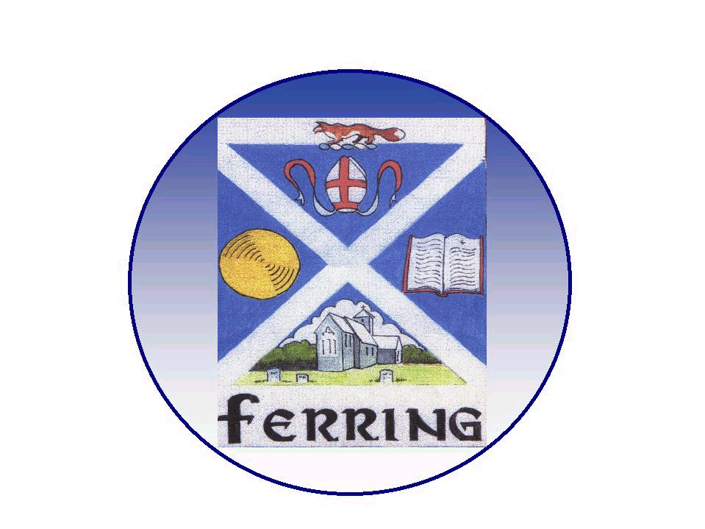
FERRING PARISH COUNCIL

1 Elm Park, Ferring, Worthing, West Sussex. BN12 5RN
telephone 01903 249 449 e-mail ferring-pc@btconnect.com

Finance and General Purposes Committee Meeting
(Advisory Powers Only)

Councillors & Parishioners

To : Councillors Carole Robertson (Chairman), Terry Jackson (Vice Chair), Roger Elkins, Peter Evans, Chris Headon, Geoff Mines, Stephen Abbott, Ruth Sims

Your attendance is requested at a meeting of the Finance and General Purposes Committee to be held on Tuesday 24th May 2016 at 8.00 pm at the Parish Office.

A G E N D A

- Apologies for absence

- Declarations of Interest - Members are reminded to make any declarations of personal and/or prejudicial interests that they may have in relation to items on this Agenda.

- Public Question Time - A Public Question Time of 15 minutes

- Matters arising from the report of the last meeting held on 5th April 2016

- Accounts and Finance - Income and expenditure (available at the meeting).

- Parish Clerk Report – The Parish Clerk will report any issues within the Parish office

- End of year Accounts – The Parish Clerk will present the end of year accounts

- Financial Regulations – Committee to consider Financial Regulations

- Consultations – HELAA (ADC) & Issues & Options (WBC)

- Village Green Play Equipment – Update and further consideration

- Neighbourhood Plan Implementation (including CRTBO’s) Committee

- Items to be referred to next Agenda and Items for Information Only

- Date of the next meeting is Tuesday 5th July 2016

Nadine Phibbs
Parish Clerk & RFO 18th May 2016

