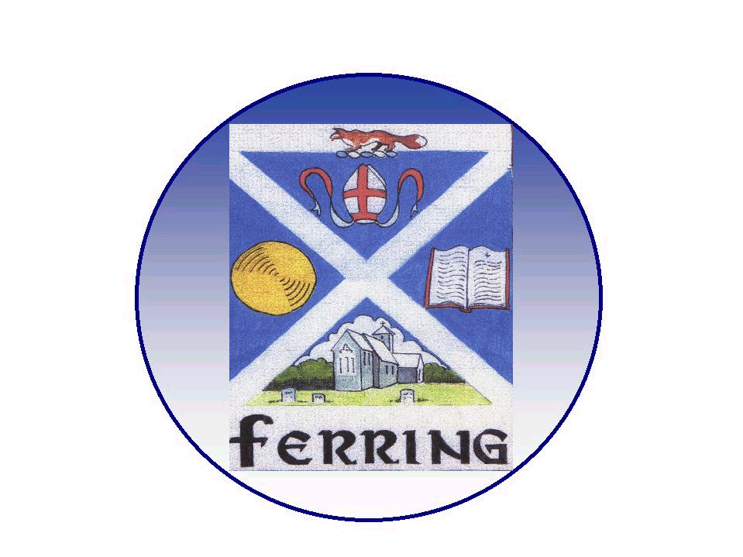
FERRING PARISH COUNCIL

1 Elm Park, Ferring, Worthing, West Sussex. BN12 5RN
telephone 01903 249 449 e-mail ferring-pc@btconnect.com

Finance and General Purposes Committee Meeting
(Advisory Powers Only)

Councillors & Parishioners

To : Councillors Carole Robertson, Terry Jackson, Roger Elkins, Peter Evans, Geoff Mines, Stephen Abbott, Stephen Horne & Ruth Sims

Your attendance is requested at a meeting of the Finance and General Purposes Committee to be held on Monday 14th May 2018 at 7.30 pm at the Parish Office.

A G E N D A

- Apologies for absence

- Declarations of Interest - Members are reminded to make any declarations of personal and/or prejudicial interests that they may have in relation to items on this Agenda.

- Public Question Time - 15 minutes has been reserved for members of the public to address the Council on any subject related to items on the agenda only. (Standing Order 1d)

Each member of the public is entitled to speak once and shall not speak for more than
three minutes. (Standing Order 1g)

- To confirm the Minutes of the last Meeting held on 26th March 2018

- Matters arising from the minutes of the last meeting

- Accounts and Finance - Income and expenditure (available at the meeting).

- Parish Clerk Report including Financial Matters – The Clerk will report any issues within the Parish office
- Out and about project 2018

- End of year Accounts – The Parish Clerk will present the end of year accounts (presentation is attached)

- Neighbourhood Plan Implementation (including CRTBO’s) Committee –
- Glebelands Purchase/Lease

- Environment Committee –
- nature Walk leaflet
- Wild flower plug plants orchard

- Pantiles Transfer – To consider Solicitor invoice & revised contracts

- Website – Update, Councillor Geoff Mines

- Urgent matters arising, since the preparation of this Agenda & Items to be referred to next Agenda

- Pursuant to Section 1(2) of the Public Bodies (Admission to Meetings) Act 1960 it is resolved that because of the confidential nature of the business to be transacted, the Public and the Press leave the Meeting during consideration of Agenda Item 13.

- Office Employment Contracts – NALC National Salary Award

- Date of the next meeting is Monday 2nd July 2018

Nadine Phibbs
Clerk & Responsible Financial Officer
8th May 2018

