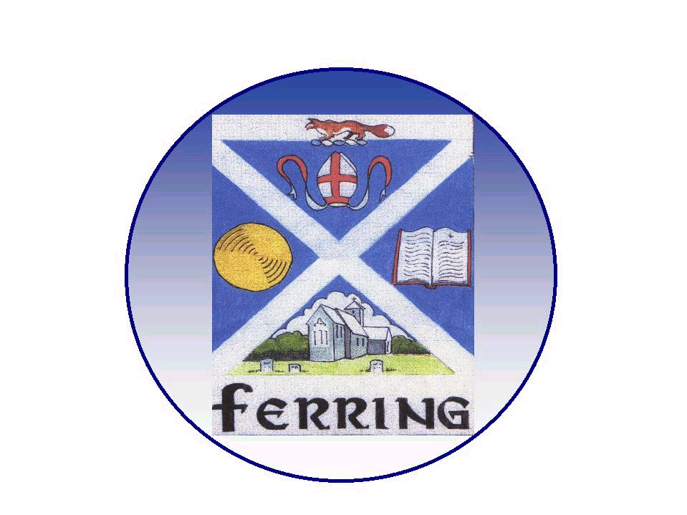
FERRING PARISH COUNCIL

1 Elm Park, Ferring, Worthing, West Sussex. BN12 5RN
telephone 01903 249 449 e-mail parishoffice@ferringparishcouncil.org.uk

Ferring Parish Council

Environment, Amenities and Footpaths Committee
(Advisory Powers)

To: Councillors - Clare Royal, Elizabeth Perry, Ruth Sims, Stephen Abbott

Greg Plenty - FRSA Gardens, Patricia Hall - Conservation Group
Philip Ellis – Tree Warden

cc: David Bettiss, Councillor Peter Coe

Your attendance is requested at a meeting of the Environment, Amenities and Footpaths Committee to be held on Monday 14th September 2020 at 7.00pm via the Zoom platform.

Due to the Coronavirus (Covid 19) pandemic, Committee meetings will be held remotely (via Zoom) in line with ‘The Local Authorities and Police and Crime Panels (Coronavirus) (Flexibility of Local Authority and Police and Crime Panel Meetings) (England and Wales) Regulations 2020’ that are currently enacted for Meetings on and up to 7th May 2021.
For further information see The Local Authorities (Coronavirus) (Flexibility of Local Authority Meetings) (England) Regulations 2020 http://www.legislation.gov.uk/uksi/2020/392/contents/made

Public Question Time, agenda item 4: Members of the Public are invited to submit questions on any subject related to items on the agenda only, for consideration at the meeting, to the Council by no later than Friday 11th September 2020 at 4.00pm either in writing delivered to the Parish Council Offices, via email to: parishclerk@ferringparishcouncil.org.uk or by telephone: 01903 249449.

Details to join the meeting will be provided upon request – please call the office on (01903) 249449 or email parishclerk@ferringparishcouncil.org.uk before 10:00am on 14th September 2020.

Please note that the Meeting will be recorded (audio), for the purpose of ensuring clarity for the Minutes.

AGENDA

- Apologies for Absence

- Declarations of Interest - members are reminded to make any declarations of personal and/or prejudicial interest that they may have in relation to items on this agenda.

- Public Question Time - 15 minutes has been reserved for members of the public to address the Council on any subject related to items on the agenda only. (Standing Order 1e)

Each member of the public is entitled to speak once and shall not speak for more than three minutes. (Standing Order 1g)

- To confirm the Minutes of the last Meeting held on 22nd June 2020

- Matters arising from the minutes of the last meeting not covered on the agenda

- Information items
a. Village Green Frontage (ADC works)
b. Beach Litter & new bins installed
c. North west corner slab at the base of the memorial is loose – Councillor Stephen Abbott
d. Crossing Bus Shelter completed

- New Projects
a. Skip for Allotments
b. Permanent structure (Statue/poppies/bench)
c. Village Green Disabled Play Equipment
d. Patterson’s Walk
e. Bench Ferringham Lane
f. Christmas tree
g. Other Projects

- Dog Control Issues/FPC Consultation Working Group – Councillor Peter Coe

- Warren Pond Clearance 2020

- Tree Matters - Phillip Ellis

- FRSA Report – Greg Plenty

- Conservation Group update – Patricia Hall

- Parish Clerk Report - including Financial Report

- Urgent matters arising, since the preparation of this Agenda & Items to be referred to next Agenda

- Date of Next Meeting Monday 14th December 2020.

Amanda Thomas
Administration Assistant
2nd September

