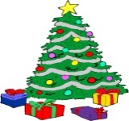**CHRISTMAS CELEBRATIONS –**The Annual Light Switch On and Craft Fair will be held on **Saturday 15th December** and the Parish Council can promise that it will be an event not to be missed! Save your Christmas Shopping for the Fair and prepare to be amazed.