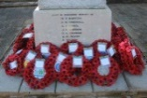
REMEMBRANCE DAY - The annual act of Remembrance organised by Ferring Parish Council and our local Ferring Churches will be held on Sunday 11th November 2018.

The Parish Family Service in St Andrew’s Church will commence at 09.30 am and will end at approximately 10.30 am. The Laying of Wreaths at the War Memorial in Ferring Street will take place after the service at 11.00 am and will include the Act of Remembrance.

PLEASE NOTE- part of Sea Lane will be closed during the laying of wreaths at the War Memorial. Advance warning notices will be posted around the village

